Reference A: The Incorporated Societies Act 2022.

B: Constitution & Rules of the Chartered Institute of Logistics & Transport NZ Inc. <https://cilt.co.nz/wp-content/uploads/2018/09/cilt-constitution-2010.pdf>

**RESOLUTION FOR CILT NZ COUNCIL TO:**

1. Update the Constitution & Rules of CILT NZ (“the Document”) to comply with the Incorporated Societies Act 2022, and
2. Promulgate the updated Document to Members by link to the revised Document on the website for their approval, and
3. Call a Special General Meeting in Wellington to formally approve the revised Document, and
4. Submit the approved Document to the Registrar of Incorporated Societies for his approval and re-registration of CILT NZ under the new Act.

Signed on behalf of the National Council.

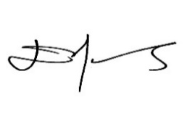

**Diane Edwards**

Ms Diane J Edwards, CMILT

CILT NZ National President

Dated: 6th October 2023