**CILTNZ COUNCIL RESOLUTION TO RE-APPOINT THE CHAIR OF THE**

**TRANSPORT RESEARCH & EDUCATION TRUST BOARD**

**AND CONFIRM THE EXISTING TRUSTEES IN THEIR APPOINTMENTS**

Reference: The Rules of the Transport & Research Education Trust Board, as amended 17th March 2008, Clause 7.3.

It is hereby **resolved** that Glen-Marie Burns, FCILT be re-appointed Chair of the Transport Research & Education Trust Board effective from 4th March 2023.

It is further **resolved** that the existing Trustees, Glen-Marie Burns, Jon Butler, Jonathan Kelly, Murray King and Cormac McBride, are confirmed in their position for a period of three (3) years effective from the date of this Resolution.

It is noted that Tony Gollin and Philip King have resigned as Trustees.

Signed on behalf of the National Council.

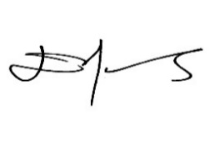

**Diane Edwards**

Ms Diane J Edwards, CMILT

CILT NZ National President

Dated: 29 September 2023