Announcement and Call for Papers

The 25th International Symposium
on Logistics
(ISL 2020)

Smart Logistics and Supply Chain Management

Seoul, South Korea

12th to 15th July 2020

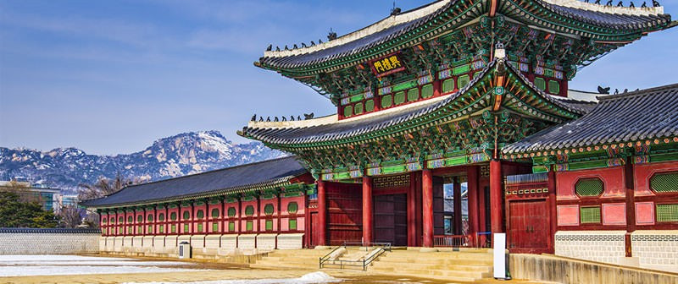

Organized by
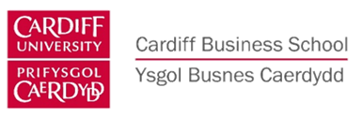

http://www.isl21.org

INTERNATIONAL ADVISORY COMMITTEE
Prof. M Abrahamsson, Linköping University, Sweden
Prof. R Accorsi, University of Bologna, Italy
Dr J Baalsrud Hauge, BIBA Germany, KTH Sweden
Prof. R Bai, University of Nottingham, Ningbo, China
Prof. R Banomyong, Thammasat University, Thailand
Prof. Emeritus D Bennett, Aston University, UK and Chalmers University of Technology, Sweden
Prof. M Bourlakis, Cranfield University, UK
Prof C Chan, RMIT, Australia
Prof. Y Chang, Korea Aerospace University, South Korea
Prof. P Childerhouse, Massey University, New Zealand
Prof. Emeritus M Christopher, Cranfield University, UK
Dr A Coronado, Royal Holloway U. of London, UK
Prof. S Dani, Huddersfield University, UK
Dr Job de Haan, Tilburg University, The Netherlands
Prof. J Eschenbaecher, Private Hochschule für Wirtschaft & Technik, Oldenburg Germany
Prof. E Ferrari, University of Bologna, Italy
Prof. M Francis, Cardiff Metropolitan University, UK
Prof. B Gammelgaard, Copenhagen Business School, Denmark
Prof. C Glock, Technische Universität Darmstadt, Germany
Prof. M Goh, National University of Singapore, Singapore
Dr S Harding, Birmingham City University, Birmingham, UK
Dr J Havenga, University of Stellenbosch, South Africa
Dr F Huq, University of Manchester, UK
Prof. M Y Jaber, Ryerson University, Canada
Prof. B Kam, RMIT, Australia
Prof. Y Karasawa, Seijoh University, Japan
Prof. O Khan, Royal Holloway, University of London, UK
Dr P Lai, Chung Ang University, South Korea
Prof. Emeritus C Lalwani, Hull University, UK
Mr P McCullen, University of Brighton, UK
Prof. T Masui, Musashi Inst. of Technology, Japan
Prof. Emeritus M Miyazaki, Tohoku University, Japan
Prof. M Muffatto, University of Padua, Italy
Prof. M Naim, Cardiff University, UK
Prof. M Ohba, Nihon University, Japan
Dr S O’Reilly, University College Cork, Ireland
Prof. R Pouraghabagher, CalPoly, USA
Prof. N Pujawan, Sepuluh Nopember Institute of Technology, Indonesia
Prof. S Rahman, RMIT University, Australia
Prof. J Schumacher, Fachhochschule Vorarlberg, Austria
Prof. J Shah, IIMU, Udaipur, India
Prof. M Singh, Inst. for Supply Chain Innovation, Malaysia
Prof. N Subramanian, Sussex University, UK
Prof. M Sugawara, Iwate Prefectural University, Japan
Assoc. Prof. T Takeno, Iwate Prefectural University, Japan
Prof. K Tan, University of Nottingham, UK
Prof. C Tang, UCLA Anderson School, USA
Prof. K-D Thoben, BIBA, Germany
Dr N Tipi, Huddersfield University, UK
Dr J Vilko, Lappeenranta University of Technology, Finland
Prof. K Wakabayshi, Nihon University, Japan
Prof. S Woo, Chung Ang University, South Korea
Prof. M Yu, Tsinghua University, China
Prof M Zhang, Queens University Belfast, UK
Prof. X Zhao, CEIBS, China

SYMPOSIUM ORGANISATION

Symposium Co-Chair  Prof. Kulwant S Pawar  University of Nottingham, UK  Kul.Pawar@nottingham.ac.uk |  | Symposium Co-Chair  Prof. Suhan Woo  Chung Ang University, South Korea  shwoo@cau.ac.kr
Programme Co-Chair  Dr Andrew Potter  Cardiff University, UK  PotterAT@cardiff.ac.uk | Programme Co-Chair  Prof. Helen Rogers  Nuremberg Institute of Technology, Germany  helen.rogers@th-nuernberg.de |  | Programme Co-Chair  Dr. Polin Lai  Chung Ang University, South Korea  polin@cau.ac.kr
Programme Co-Chair  Dr Christos Braziotis  University of Nottingham, UK  Christos.Braziotis@nottingham.ac.uk | Paper Submission Management  Dr. Abhijeet Ghadge  Cranfield University, UK  Abhijeet.Ghadge@cranfield.ac.uk |  | Symposium Administration  Ms Maeve Rhode  University of Nottingham, UK  Isl21@nottingham.ac.uk

SUBMISSIONS

Abstract Deadline for working papers, and for full papers requiring peer review: 7th February 2020

The decision regarding acceptance will be made by the middle of March 2020, and accepted papers must be received in full, within the layout guidelines (see www.ISL21.org) by 11th May 2020.

SEOUL, SOUTH KOREA

From modern skyscrapers and neon lights to Buddhist temples, palaces and pagodas, Seoul is a fascinating mix of old and new. A hub of business, culture and finance both within South Korea and internationally, Seoul houses the headquarters for some of the world's largest corporations.

Seoul is also a place of considerable tradition and history. Joseon-dynasty palaces proclaim its status as a seat of regal power from as far back as 1392; the tiled roofs of wooden hanok houses gently fish-scale their way towards the ash-coloured granite crags of Bukhansan, the world’s most-visited national park; the ancient songs and dances are still performed along the street of Insadonggil.

It also has one of the world's best subway systems, the easiest way to get around in this densely populated area as well as to explore South Korea more widely.

